# Melody lines for hymns used at Stations of the Cross

All ye who seek for sure relief

Be still, my soul, the Lord is by thy side

Brother, sister, let me serve you

From heav’n you came, helpless babe

For Mary, mother of our God

Glory be to Jesus

It is a thing most wonderful

Just as I am, without one plea

My God, I love thee; not because

My song is love unknown

O crucified Redeemer

O dearest Lord, thy sacred head

O love, that wilt not let me go

O sacred head, surrounded

Take up thy cross the Saviour said

Teach me, my God and King

The Servant King

There is a green hill

Thou are the Way

We sing the praise of him who died

When I survey the wondrous cross

Who would true valour see

**1. Love unknown**

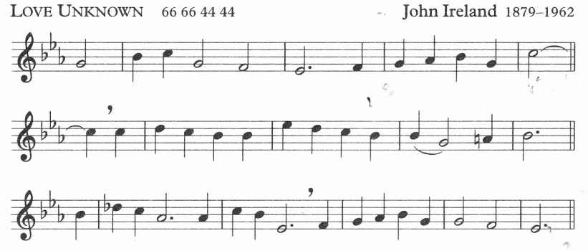

**2.** **Breslau**

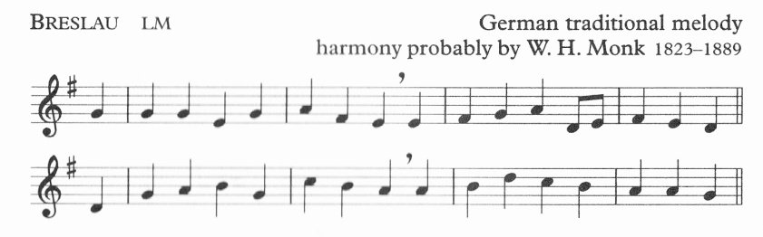

**3.**  **St Bernard**

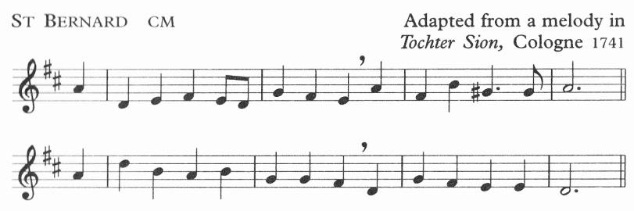

**4.** **St Francis Xavier**

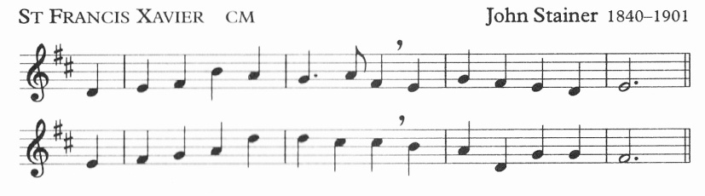

**5.** **Caswall**

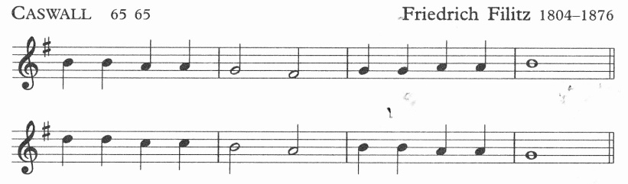

**6.** **Rockingham**

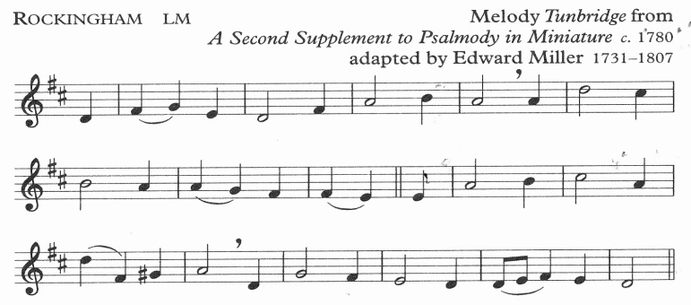

**7.** **St Botolph**

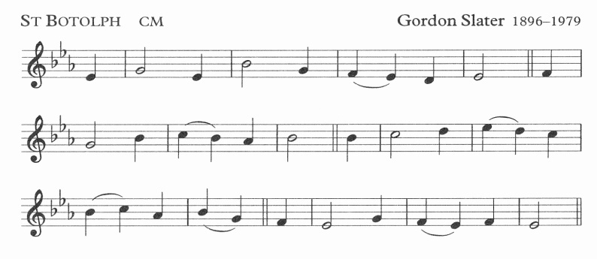

**8.** **The Servant King**

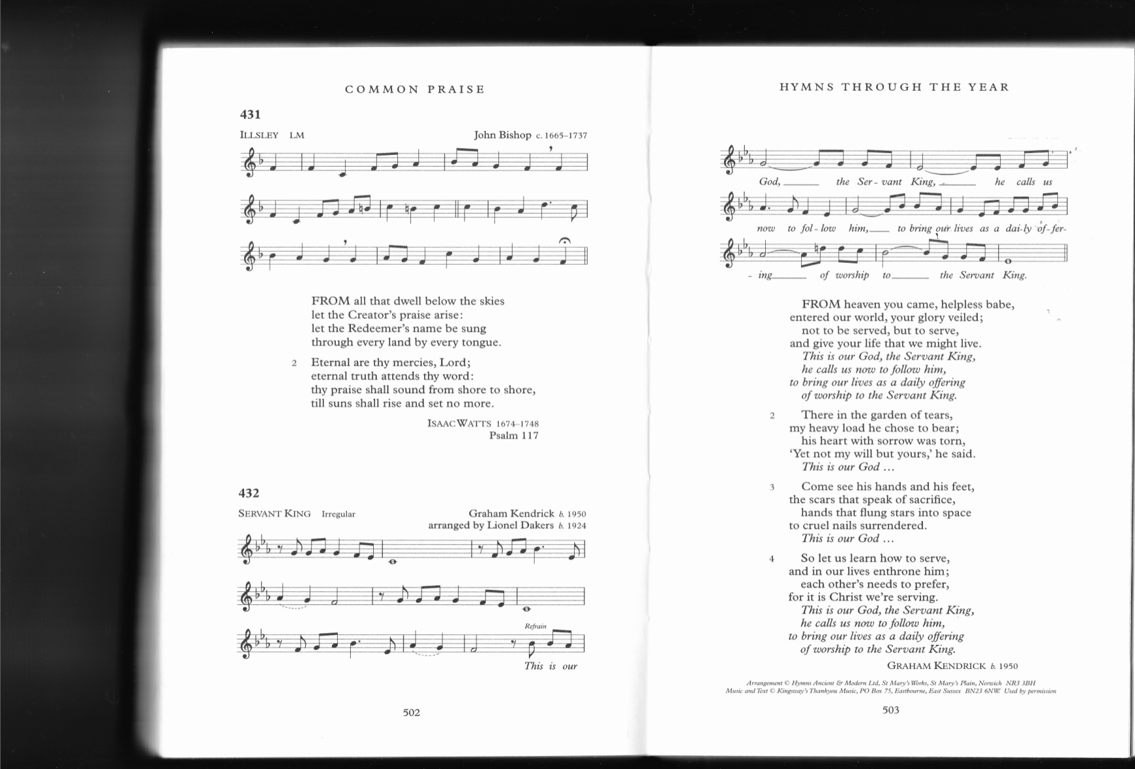

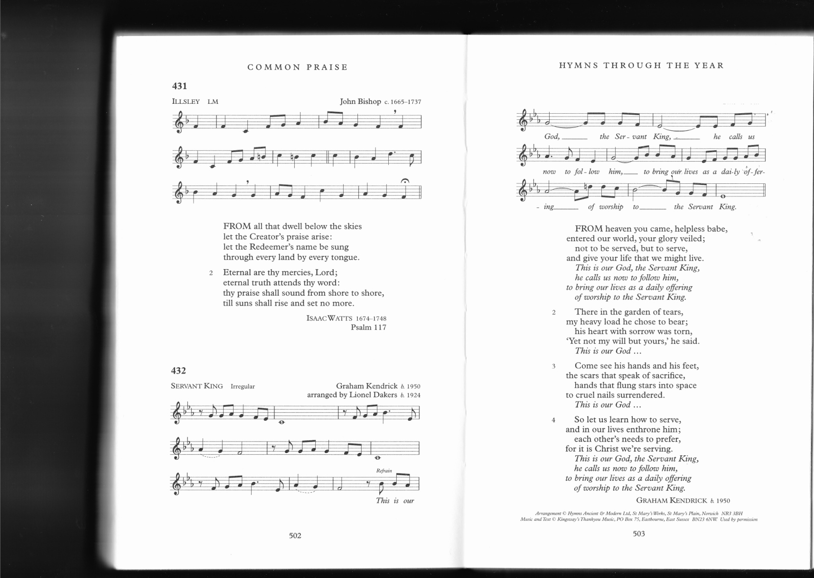

**9.** **O sacred head, surrounded**

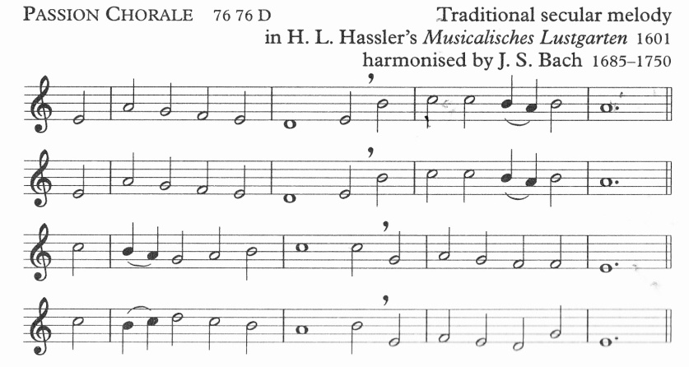

**10** **Herongate**

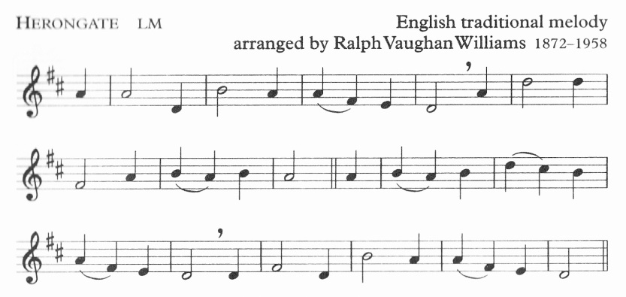

**11** **Servant Song**

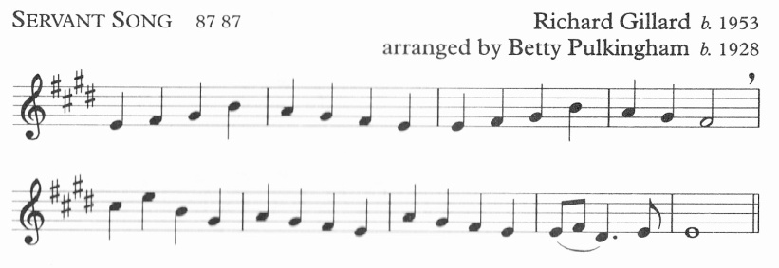

**12** **St James**

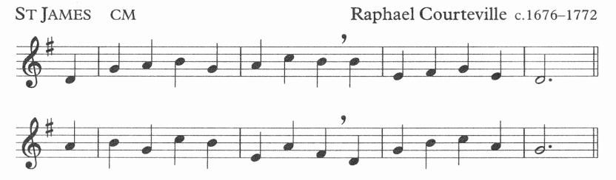

**13 Sandys**

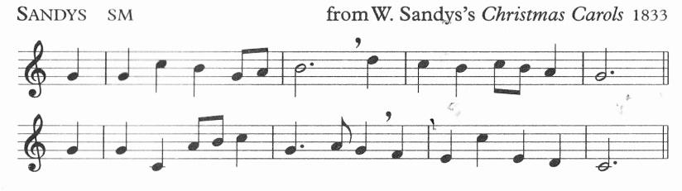

**14** **Love unknown**

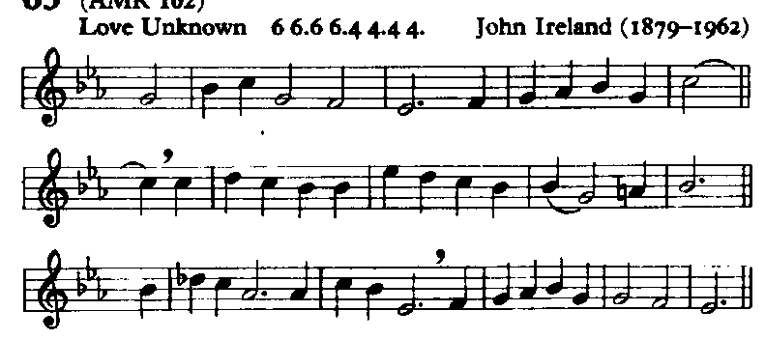

**15** **Horsley**

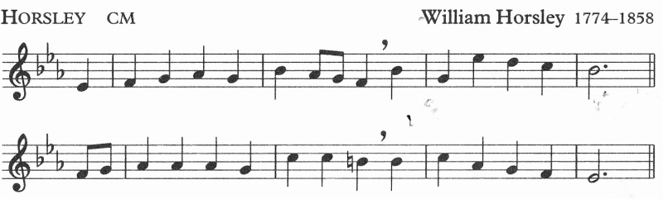

**16** **Saffron Walden**

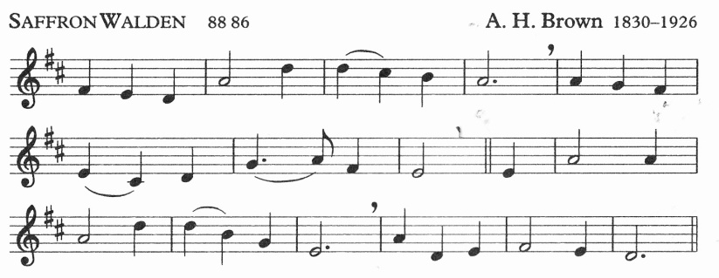

**17** **Bow Brickhill**

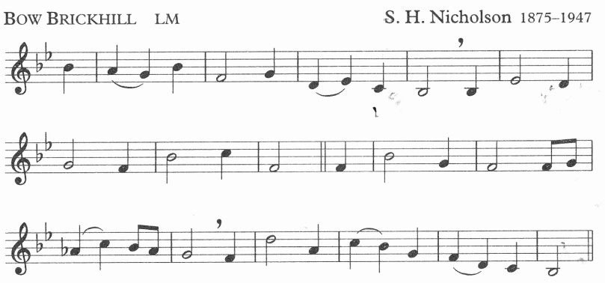

**18** **Finlandia**

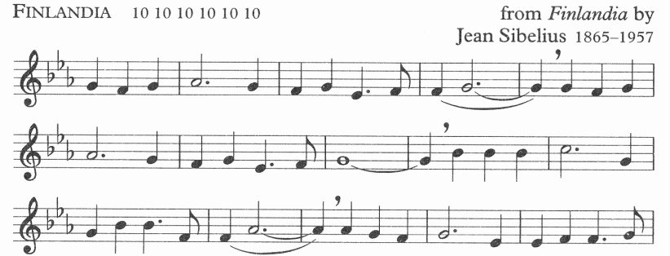

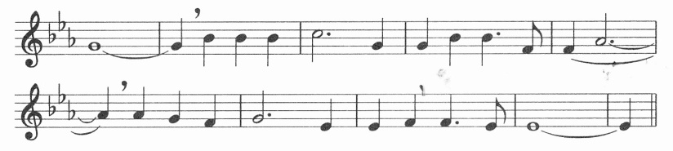

**19** **St Margaret**

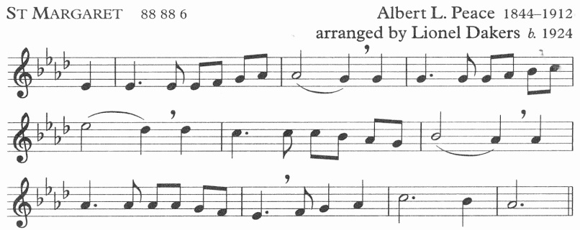

**20** **Llangloffan**

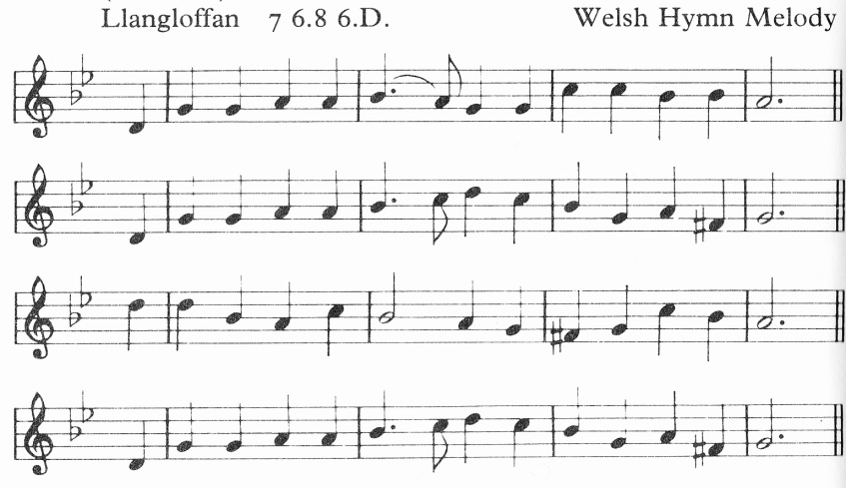

**21** **Monks Gate**

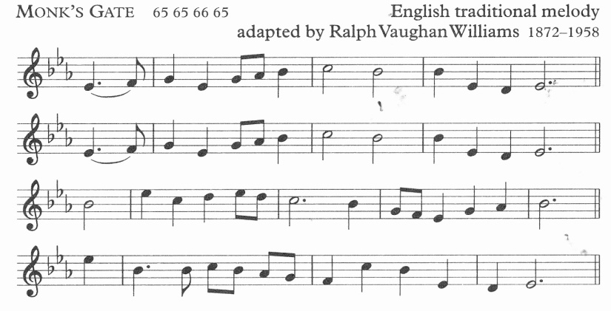

**22** **Albano**

